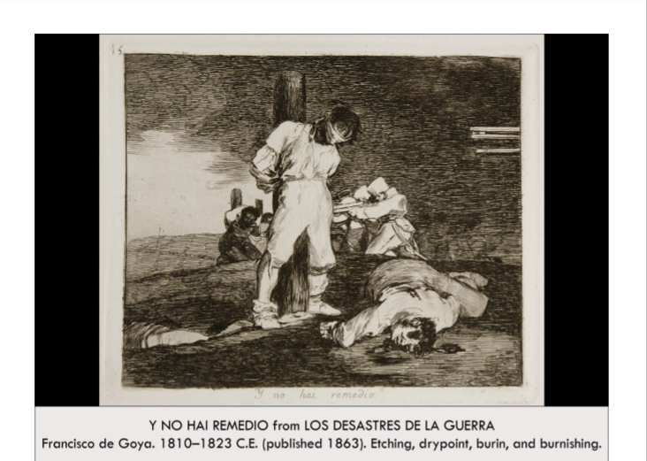

| **Form:** Black and white, Man wearing light-colored or white tied to a pole by his hands (behind his back)- He is blindfolded. The landscape has some depth and the scene is dark. There is a firing squad behind the central figure facing similarly bound people (also tied to poles) On the central figure’s right side → there is a body contorted on the floor → likely dead. There are rifle barrels pointed at the central figure coming out from the right side of the painting. The people holding them are occluded  **Function:** Meant to protest the French occupation and the brutality against the Spanish people, “Y no hay remedio” belongs to the first group of plates. Show conflicts between French troops and civilians → consequences. Showing that war brings out the inhuman in people  **Content:** A man is tied to a pole → *Alter Christus* → an “other Christ. Behind him are other poles with men tied onto them and firing squads either firing or ready to fire. The body on the ground is grotesque, mangled, with blood and brains leaking (Eyes are gone, body is contorted, Possibly showing that he was recently shot) The rifles coming from the right side of the print are aimed at the central figure tied to the pole  **Context:** Disasters of war was created from 1810-1820. 82 images meant to protest against the French occupation of Spain by Napoleon Bonaparte, There was an uprising and a lot of Spaniards died. The French were pushed out after the Peninsular war → very bloody conflict, also satirizing Spanish socio-economy → which caused people to live in poverty. First plates → effect of conflict, Middle plates → effect of famine, Last plates → disappointment and demoralization of Spaniards. Each the plate → cover the metal plate with wax, carve out the shapes, dip in acid so that the acid goes into the incisions, melt off the wax and the incisions remain. Drypoint → scratch lines on the surface with a stylus → create a less even line. Then the artist pours ink on the plate and wipes it off so that it only remains in the spots where the acid burned or the artist etched. Moist paper is put on the plate → run through a press. Goya Worked as a painter for the French and Spanish royalty, His work was so controversial, Prints intended to install Spanish nationalism. **Themes:** Power and authority, The human psyche= Psychology, human monsters, the inhuman in humans, Violence and terror, Art as a form of protest  **Compare:**  **106**  Late Europe & Americas |
| --- |

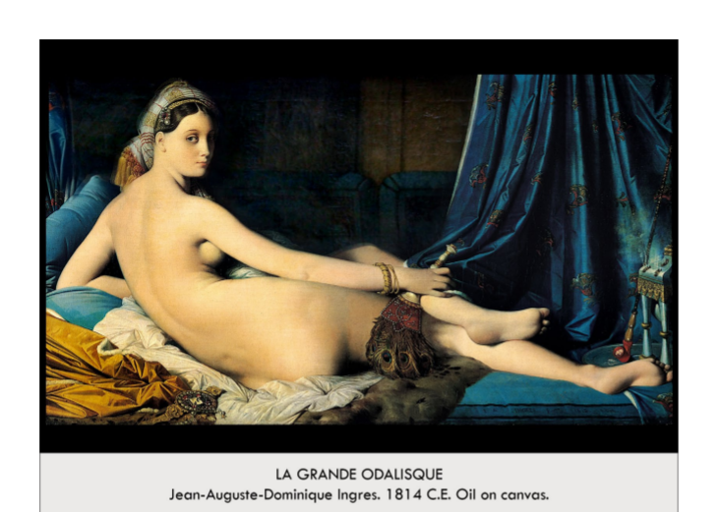

| **Form:**  Oil on canvas. Shows a combination of classical draftsmanship, mannerist proportion, and romantic themes. Converted a neoclassicism figure into an odalisque with romantic tastes.  **Function:**  Decoration. Painted for Napoleon's sister Caroline Murat= queen of Naples.  **Content:**  Shows a reclining nude female figure— which follows the grade tradition of antiquity abnd the renaissance Themes: sex, luxury. About a north african ket women. The spine is impossibly long (mannerism) and she is not realistically proportioned. Figure is in a languid pose, small head, and elongated limbs and torso, generally cool color scheme reveal the painters dept to parmigianino and the italian mannerist, sculptures and painters.  **Context:**  Takes on theme from ornamentalism. A time when harem girls becomes an object of fascination: obsession with all things egyptian and moroccan. Shows artists admiration for rafael in his borrowing of that masters type female head. By converting the figure to an odalisque ( women in turkish harem) he makes a strong concession to the burgeoning romantic tast for orientalist subjects. First exhibited in 1814and drew much criticism. He did not support the romantic movement.  **Compare:** the rocavine venus by valances, titans vinis of verbena  **107**  Late Europe & Americas |
| --- |

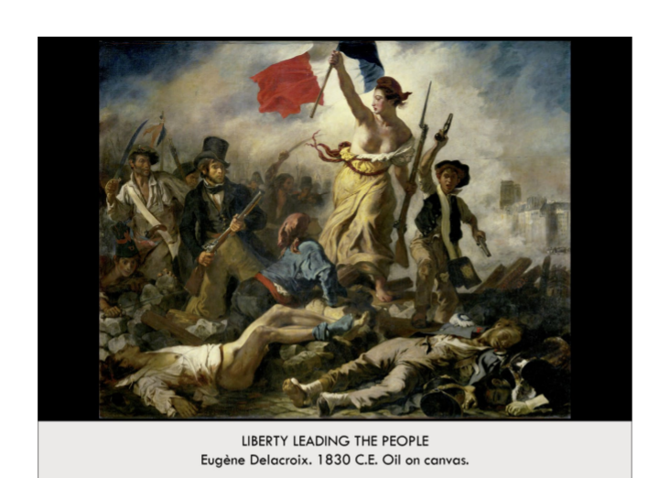

| **Form:** medium: canvas; oil on canvas. Realistic, but with dramatic, theatrical lighting. Soft, rounded lines that embody the figures depicted more so than the sharpness of their objects. Depth and foreground but little to no background; shrouded in a cloud of fog (theatrical effect?)  **Function**:Glorification of everyday people who were involved in the war and the role of France's citizens in that war. Acknowledgment of the sacrifices civilians made for the sake of revolution against a corrupt governmental regime. Takes on a poignant tone as the revolution would be thought by some to have been in vain; pre-Napoleonic rule. A balanced mix of history and poetic allegory.-- a record of contemporaneous event and a romantic allegory.  **Content**: the main subject is the bare breasted Personification of Liberty (central figure)- thrusting forth the republic tricolor banner as she urges people to fight. She has a scarlet cap ( symbol of a freed slave in antiquity) Marching over dead bodies, Leading the way to freedom. Carrying flag of revolution and a musket in her hands. Young boy holding two pistols, Represents sacrifice. Upper-class gentleman in a top hat, holding a rifle, Represents the rich's inability to stay out of the war. Captures the passion and energy of the 1830, Parisian Uprising against Charles x. Dead bodies in the background, towers of notre-dame through smoke and haze  **Context**: Romanticism/during Romantic period. Based on July Revolution of 1830. Lasted 3 days.  **Compare:**  **108**  Late Europe & Americas |
| --- |

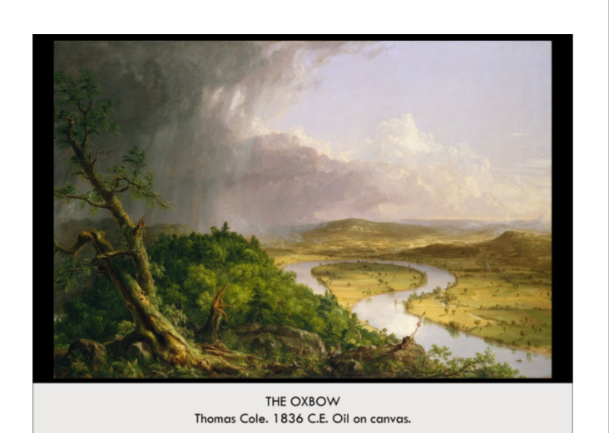

| **Form:** Oil on canvas. View from Mount Holyoke, Northampton Massachusetts, after a Thunderstorm- The Oxbow. 1886 by Thomas Cole, Realistic but cartoon in an exaggerated way; like a caricature.Warm hues (yellows and greens) for nature, dark, cool colors for weather (grey, blue)  **Function:**References the bend in the Connecticut River. Reminder of humanity's insignificance in the grand scheme of things (as applies to many works created during the Romantic movement)nineteenth-century political ideology: this painting is about the widely discussed topic of westward expansion. This part of the painting depicts a virginal landscape, nature created by God and untouched by man. It is wild, unruly, and untamed. Exploration of A persons relation to country and nation  **Content:** Left half is pur wilderness with a storm coming in, the wilderness in untrammeled. And on the right half there is civilization and it has been groomed. = shows an oxbow( bend in the river) the viewer can clearly see that Cole used a diagonal line from the lower right to the upper left to divide the composition into two unequal halves. Tree being bent: Symbol for nature being at the mercy of itself. River, Clouds: Stormy in the foreground, white and clear sky in the background (far corner) This is enhanced by the gloomy storm clouds that seem to pummel the not-too-distant middle ground with rain. A miniscule painter at the bottom center  **Context:** Hudson river valley in New york state. View from mt hulio in upper massachusetts. Posing the question should we cultivate wilderness or should we leave some. (Hudson River School founded by artist, Thomas Cole) "Thomas Cole (1801 - 1848) was the founder of the Hudson River School. In his painting *The Oxbow*, Cole has chosen a dramatic vantage point from which to view the twisting Connecticut River. A large tree in the foreground has been battered by weather, while the river is far in the valley below. Above the tree are fierce thunderclouds, while the distance shows the sky after the storm has passed. The only trace of man in this scene is the artist wearing a hat in the lower center of the canvas."he was referred to as the leader of the hudson river valley school  **Compare:**  **109**  Late Europe & Americas |
| --- |

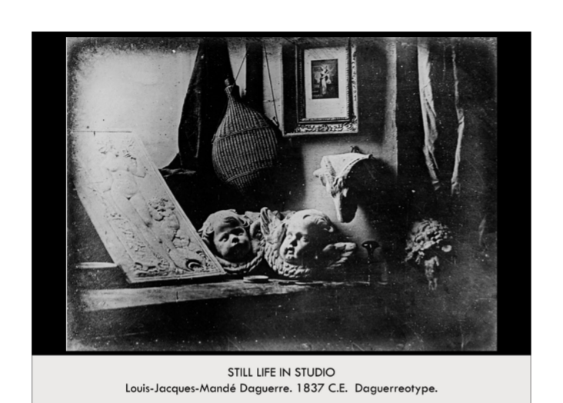

| **Form:** It is an image on a metal palat. A photograph(light-wrighting) created by using mercury - which was every toxic. "Each daguerreotype is a remarkably detailed, one-of-a-kind photographic image on a highly polished, silver-plated sheet of copper, sensitized with iodine vapors, exposed in a large box camera, developed in mercury fumes, and stabilized (or fixed) with salt water or “hypo” (sodium thiosulphate)." Black and white; no usage of color, only gray areas in between.  **Function:**Was created to demonstrate the effectiveness of his camera and how well a photograph can capture an image. Duality:Medium of artistic expression, Powerful scientific tool, Artists feared photography would eventually supplant painting, Photography was in itself an art form; even if not considered such at the time  **Content:**  Anb image of a plaster caste which art students would use t learn how to draw. One is a bai-relife of vines, an etching in a background and a piece of cloth. Anatomy of a daguerrotype =One-of-a-kind image on a highly polished, silver-plated sheet of copper. Handful of still lifes, Parisian views, and portraits from the dawn of photography. Images of other works of art..Sculpture, painting, photography, etc.  **Context:**  The image is a one off, and cannot be reproduced. Created by one of the first creators of photography. Louis-Jacques-Mandé Daguerre (1787–1851) Daguerrotypes accompanied the invention of photography. Less than 25 of his photos survive the devastating fire on March 8, 1839  **Compare:**  **110**  Late Europe & Americas |
| --- |

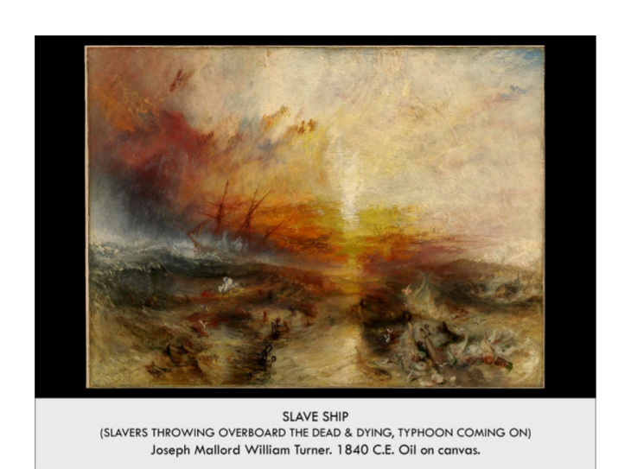

| **Form:** Abstract, fabricated quality. Makes it difficult to discern the subject matter and the action of the scene."Turner uses intense colors and turbulent brushstrokes to convey the heightened emotion of the event. Emotional power of color, expresses both forces of nature and his response to them.  **Function:** Wanted to protest any reconsideration on the subject, Prevent slavery from ever becoming a normalized practice in the future with a harsh reminder. To shock the critics and general audience into seeing just how brutal slavery could be, and why it shouldn't ever come back. Tell a story= Moral of the story being you are morally condemned if you participate in such a horrific, dehumanizing practice. Slave ship is doomed to wreck because of the actions of its captain. 'Communicate sympathy and judgment'  **Content:**  A ship (slave ship) sailing directly into a storm, abandoning the slaves that were thrown overboard to drown, Fiery sunset, writhing foam and waves. Fish with teeth chomping at the slaves' chained limbs. A wall of water and grey clouds dooming the ship to shipwreck (as punishment and vengeance for the death of slaves; upsetting of the balance of nature) Body parts, still shackled and being attacked by sharp-teethed fish, can be seen in the central and right foreground. Matches the barbaric nature of the image.  **Context:** J.M.W. Turner (1775 - 1851). Twenty or so years before Impressionist movement; Turner uses techniques that are not yet popular, Man vs. nature (popular theme during late 1700s and early 1800s. Slavery was banned in Britain, but not in some of the countries it had colonized (e.g. the United States of America)  **Compare:**  **111**  Late Europe & Americas |
| --- |

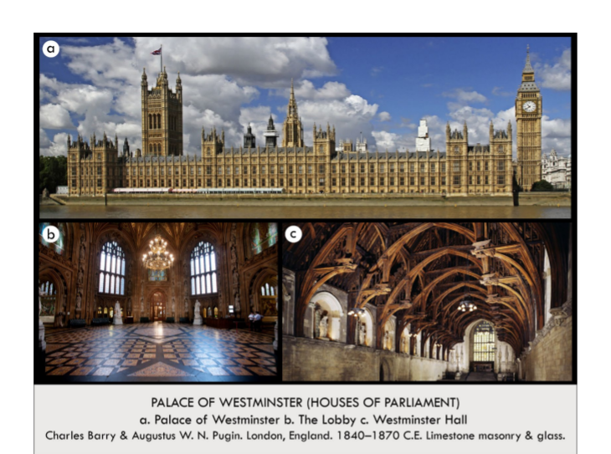

| **Form:**  In the gothic perpendicular style. Made of limestone masonry and glass. Was intended to be either Gothic or Elizabethan. In the style of Gothic only (late medieval period; Shakespearean times)  **Function:**  As a house of parliament-US government. Primary function; practical and not based in aesthetic appearance, more so the reinforcement of traditional values. Still today the seat of government, House of Commons, House of Lords.  **Content:**  Augustus Plugin. Interior designs + stained glass, Gothic style  **Context:**  Westminster hall is the only original, which was not rebuilt. Across from River Thames. Among Houses of Parliament in London, Built in the early Victorian era. The Great Fire in 1834 burned down the original; had to be rebuilt. Competition held to see who could build the best replacement - won by Charles Barry and Augustus Plugin. English 19th century  **Compare:**  **112**  Late Europe & Americas |
| --- |

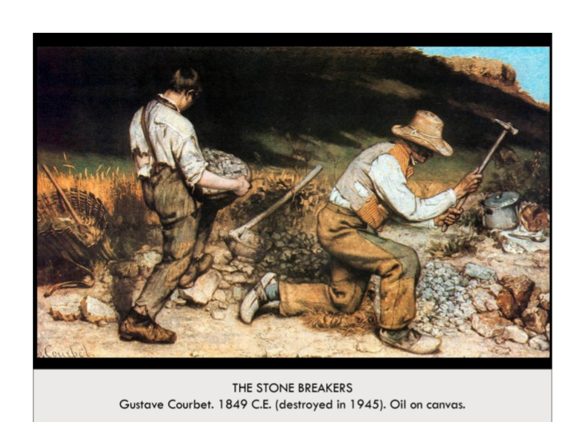

| **Form:** Created by Courbet. It was created at a massive scale (8ft ). Shows a perfect realism( painting everything how it looked) Large canvas sizes were usually reserved for important historical paintings; Courbet instead states the importance of the commonplace workers.  **Function:**As decoration, because he wanted to. To show poverty and the struggle of working-class peoples in Europe around 1850, especially given recent injustices and the fact that they were never portrayed in art.  **Content:** Breaking stones down to rubble for pavement; theme of poverty; tattered, ripped, patched clothing; using hammers and smithing tools. Shows working class realistic people, it is realism and they sky is empty. It is not pretty but different and very proactive.  **Context:** Was destroyed in WW2. this is a reproduction. People hated this painting. Manifesto of what the new art was going to be. ( realism was never popular) created during the mid 1800s. Submitted to the Parisian Salon of 1850-1851 as a reaction to the labor unrest of 1848 (people had demanded better working conditions.) Emphasizes two figures, who will be poor their entire lives, to show the unforgiving passage of time and the lack of social mobility for people of the time.  **Compare:**  **113**  Late Europe & Americas |
| --- |

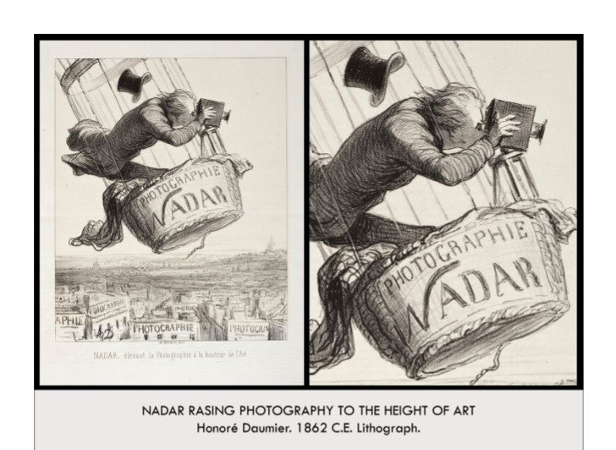

| **Form:** a lithograph (printing from a stone or smooth metal plate to produce mass images.) : putting ink on stone using wax and water to make a reproduction of it. ( wax crayon and a print making method)  **Function:**As a cartoon for a magazine. To mock Nadar; to show that ridiculous and dangerous means have to be used to elevate photography to the height and importance of "high art." Serves as a commentary on the 1862 court decision permitting photography to be seen as high art.Also foreshadows modern aerial-surveillance photography; Nadar's balloon was used in the 1870 Siege of Paris for intrusive photography.  **Content:** Showing Nadar right above paris ( in a balloon) and all the buildings are obsessed with ( raising photography to the level of fine are literally) All buildings in Paris below have "Paris" written on them.  **Context:** Daumier was a cartoon illustrator and was published in magazines, created humorous works. He was the great photography portoratrist and loved ballooning. Nadar was famous for taking aerial photos of Paris since 1858. Daumier depicts Nadar as a bizarre, daring photographer; Nadar's hat is flying off, and in his own excitement to capture the perfect shot, he almost falls out of his balloon. Daumier mocks the new declaration that photography could be equal to "high art;" it's an ironic artwork. Appeared in a journal called Le Boulevard.  **Compare:**  **114**  Late Europe & Americas |
| --- |

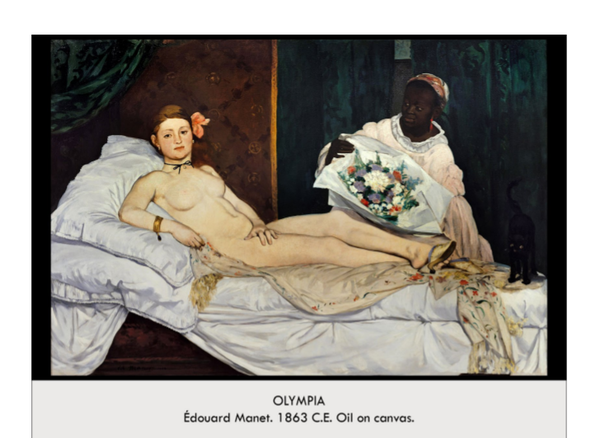

| **Form:** Realist version of what a naked person looks like. Imperfect, harsh style depicting a woman in a manner that does not fit the classical “ideal” and ethereal image of the body. Flatly painted, poorly contoured, abrupt shift in tonality, lacking depth and washed out. No vanishing point or recognizable perspective- hard to understand in space. Loose, choppy brush strokes (clearly a painted representation)  **Function:**We don't really know/decoration. Rebel from previous convention and depict harsh realities of Parisian life, Ordinary people and unglamorous prostitution. Commentary on racial divisions and the class system in Paris  **Content:** Depicts a naked(not nude) women seen in a realsitic mannor, the woment is a prostitute. Nude woman reclining on a chaise lounge with a black cat at her feet, She stares with a cold, stark, indifferent expression at the viewer. A black female servant stands behind her holding a bouquet of flowers (a gift for the prostitute from a client)- Highlights the french colonial mindset and injustice in society, the stark contrast of the black skin from the white highlighted racial division. Depicts the world of Parisian prostitution, Depicted marginalized people in society rather than the traditional Bourgeois and aristocratic subjects  **Context:** Was attacked because people hated this painting so much. It is defiant. A realist model taking from a european classic. This is a salon painting (academic painting) that defied tradition creating an artistic revolution. This received extreme negative reviews from critics in 1865 at the Parisian Salon. It “bewildered” the Parisians and was seen as scandalous and an insult to tradition. Both a nude prostitute and a black maid was seen as inferior and animalistic sexuality- Manet mocked the revitalization of classical style by using a contemporary, ordinary subject. He suggested that the classical past no longer had relevance in the modern world.Manet rejected controlled brush strokes and seamless illusionism Time of the industrial revolution (linked to the separation from the outdated, classical past) He recreated the Venus of Urbino but Manet’s creation was believed to be disrespectful and insulting to it. Manet referred to as the father of impressionism, his “rebellious” style inspired future work. Considered the first modernist painter in his technique and subjects. Manet’s realist predecessor was Gustave Courbet and drew inspiration from Velasquez and Goya and Dutch painters. The model was Victorine Meurent. “Olympia” was a common name for prostitutes  **Compare:**  **115**  Late Europe & Americas |
| --- |

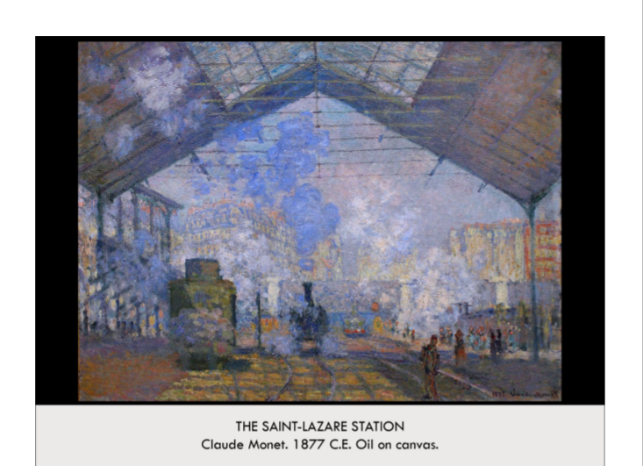

| **Form:** Created in an impressionist style. Oil on a white canvas( didn't use to use many white canvases before) Gritty texture, Follows a traditional landscape painting. Trees frame the center of the painting. Diagonal lines of the roof recede backwards into the painting.  **Function:** Emphasis on the painting's surface and paint, To capture the industrialization and modernization of Paris. For Monet to establish himself as a relevant, valuable artist in French society as it industrialized(Industrialization was such a massive societal shift that it could not go ignored by anyone who felt themselves an engaged member of society.) To capture a beautiful moment in time in the busy, urban streets of Paris, Comings and goings by train into Paris -- day-to-day,Modern bourgeoisie emerging as center of the society.  **Content:** This shows a scene of the saint-lazare station of the trains coming and going. Locomotive train pulls into the station, under triangular roofing. Steam dissolves into the air. Perspective lines and foreshortening used expertly to create the realism of the train. NO traditional lines or contours; very innovative and atypical modeling. Brushstrokes are all impressionistic. Accurate renditions of color  **Context:** Created during the time of impressionism( reality,Daily life, Speed, Avante-garde). Created by Manet who was one of the first great impressionist painters. This painting was one of his later works. Monet wanted to be remembered as an painter of the 'modern' world. Monet lived in Argenteuil, a province outside of Paris (rural) Monet commuted into Paris via the Gare Saint-Lazare, or the Saint-Lazare Station, The station was a symbol of modernity and industrialized commuter railways.Produced in 1876-1877, just a few years before the first Impressionist exhibition. The roads and train stations of Paris had recently been renovated and modernized under Baron Haussmann Unusually modern and industrial for Monet; he usually painted water-lilies. The industrial revolution, train station, bran-new architecture. Was part of a series( a mature manet, his time of painting in series/serial painting) shows the harmalks of impressionism, about reality, speed, a response to photography. The aim to to express light and color above everything else.  **Compare:** 36 views of Mt. Fuji/ Japanese art (serial art)  **116**  Late Europe & Americas |
| --- |

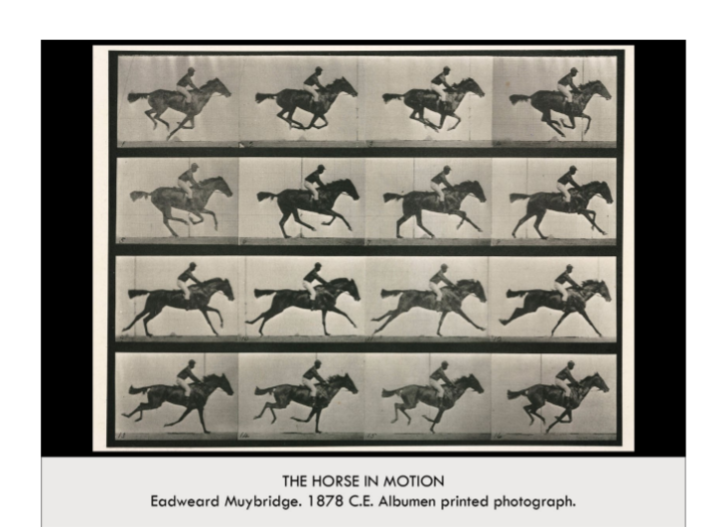

| **Form:** Albumen printed photography. 16 still photographs combined in a series. Horse and jockey are in profile (seen from a bystander’s view on the side of the track). While each individual still of the horse and jockey is beautiful, the importance of the work lies in its numbers. Together, the images tell a story—Elevate photography from still to motion by multiplying the images represented  **Function:**Documentary photography. To prove a bet. Motion study of a racing horse and jockey. To establish the impressiveness and potential of photography. Bridged the gap between still photography and moviemaking  **Content:** Shows a horse galloping using a type of photography to show the individual frames of a movement. 4 rows and 4 columns in a rectangle. Each box is a still shot of a racing horse with a jockey. Each still captures a different moment in the horse’s stride. Collectively, the photos create a sense of movement; the viewer envisions a running horse instead of a single-moment shot of a horse.  **Context:** The governor of california leland stanford made a bet with his friends of a horses feet leave the ground while running and stanford hires Muybrigdge to find out an it took about 7 years to build and conceive of the idea. Inventing film (in a way) Photography was expanding our world at the time. Photography had advanced far enough to be able to capture moments that the human eye couldn’t. Cameras took stills at evenly-spaced points on a horseracing track to create the illusion of continuous motion.Used a device called a “zoopraxiscope”  **Compare:**  **117**  Late Europe & Americas |
| --- |

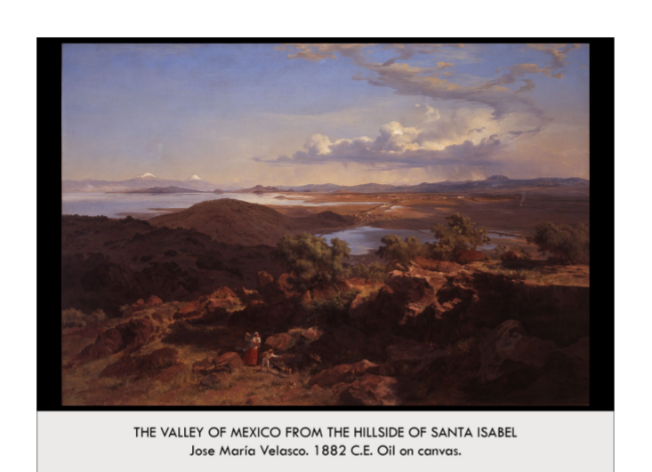

| **Form**: Atmospheric perspective and tiny human figures both create a sense of monumentality and awe of nature. Viewer stands above the mountains; looks down to survey the scene.  **Function**: Showcases the rolling red hills, magnificent blue skies, puffy white clouds, the lake, trees, and natural beauty of the Valley of Mexico. To glorify the Mexican countryside  **Content**: Mountains, lake, trees, clouds, blue skies, tiny human figures, All from the vantage point of the mountaintop village Guadalupe that looks over the Valley of Mexico  **Context**: Movement: Realism. Velasco was an academic landscape painter, specializing in panoramas of the Valley of Mexico , Velasco meticulously observed nature: rocks, foliage, clouds, waterfalls. Rejected the realistic landscapes of Courbet and Romantic landscapes of Turner  **Compare**: hudson river valley, thomas cole  **118**  Late Europe & Americas |
| --- |

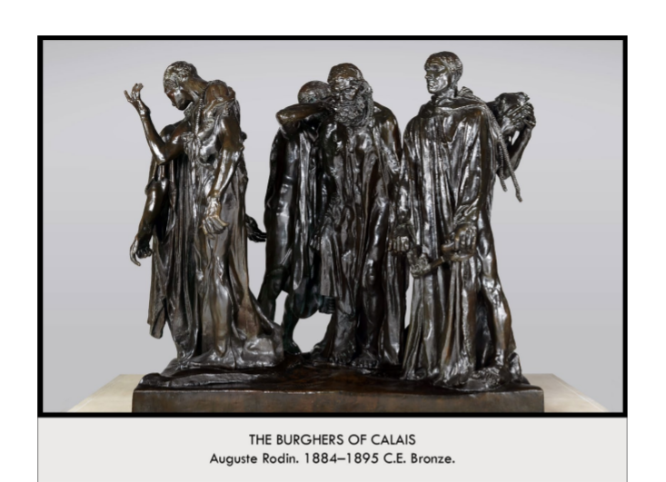

| **Form:** caste of bronze. Very realistic. All 6 characters were sculpted individually, then arranged by Rodin as best as possible to create a unified effect, Each figure represents a different emotion (fearful, resigned, forlorn), The figures are emaciated; weak. Details of the figures are reduced by Rodin to emphasize the overall impression of the 6 figures’ depravity. Figures meant to be seen at ground-level and close-up (to be relatable)  **Function:** As a commission for that town of Callay , to commemorate a story of the Burghers during the 100 year war, when they sacrificed themselves. Parallels between occupied Paris in the Franco-Prussian War of 1870 and occupied Calais by the English in 1347  **Content:** During the 100 years war town was going to be cursed by english and town fathers said just take u sand they took them that spared the town, so the town has a dept to gratitude and they are being commemorated in this statue. Each is weak and emaciated and each has a different emotion. There are 6 of the Burghers shown here. 6 “burghers,” or middle class people (people of the burgh/village) Central character is Eustache de Saint-Pierre, Has large swollen hands and a noose around his neck, He’s ready for his execution, Symbolizes the severity of the occupation/war in Calais/Paris  **Context:** Was a symbolist. Perisian sculpture, who was very famous. One of the 4 great post-impressionists. Commissioned by the town of callaway. The town father rejected it people it was not heroic but it was too real. Was meant to be seen at ground level- not heroic. “Late-1800s Sculpture,” followed the Realism artists. The town council of Calais, France rejected it- they wanted a statue of a single, allegorical figure. The English king (in 1347, Hundred Years’ War) made the burghers wear sackcloths and carry the key to the city of Calais  **Compare:**  **119**  Late Europe & Americas |
| --- |

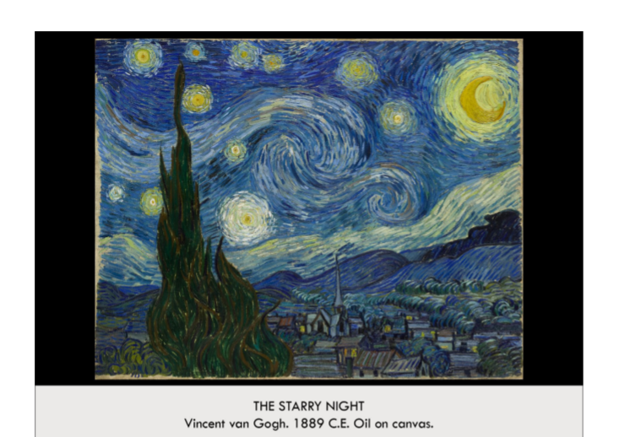

| **Form:** Oil on canvas. Heavy impasto paintings(very thick paint) Composite landscape, short, thick brushstrokes, parts of canvas can be seen through the brushwork. did not need to fill in every bit of the composition. Post-Impressionist Characteristics:dynamic brushstrokes, non-naturalistic, vibrant color that exaggerates and accentuates, rather than representing reality, painterly in quality, inspired Fauvism (later movement)  **Function:** to express what he saw. A landscape study, or a study of the nighttime, expression of the artist's internal turmoil (suffered from mental illness). Desire to experiment with stylized techniques  **Content:** Painting from the imagination in some way, not from reality, a combinations of things he had seen or experienced. Landscape view from artist's hospital room in St.-Rémy, Mountains in the distance (actual steepness exaggerated in painting). Composite landscape: Dutch church, crescent moon, Mediterranean cypress tree, Wave-like movement flows left to right, broken only by verticality of cypress and church steeple. Cypress tree a traditional symbol of death and eternal life. reaches up to the sky, dominating foreground closest to artist, symbolism.  **Context:** He was one of the few post-impressionist. He would do his own think and was independent. He sold only one painting in his life time. He was the emotional artist of the post-impressionist. Struggle with mental illness, painted during his convalescence at mental hospital near St.-Rémy, following breakdown in which he mutilated his own ear.  **Compare:**  **120**  Late Europe & Americas |
| --- |

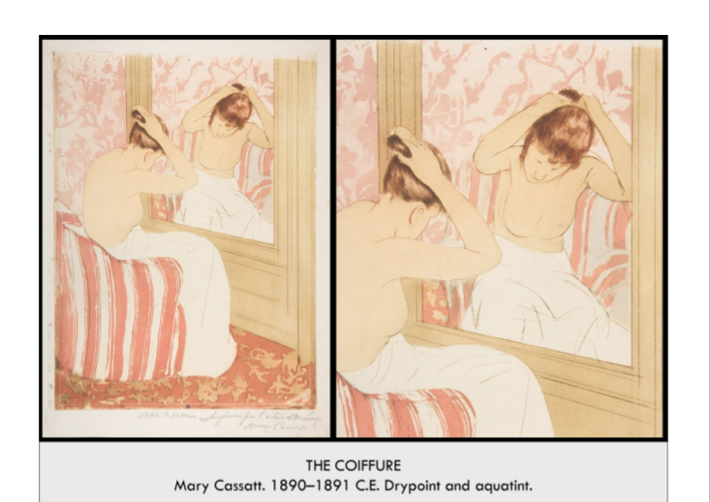

| **Form:** Colored etching. In the style of Japanese prints. light brushstrokes, sketchy, reproducible print (on paper). **Artist:** Mary Cassatt, 1890-1891, drypoint and aquatint on paper. Post-Impressionism  **Function:** As decoration, to be collected. To make artwork more accessible to all classes, created easily reproducible prints, less expensive, widespread availability. Cassatt was advised against this, critics said it would make her art less valuable, she insisted on this principle of art for the masses. Cassatt had a prescient understanding of how photography would come to affect the art world. art can no longer be elitist and elusive. it will be available "to the masses" whether artists like it or not, so it was smart of her to jump on board with the wave of technology rather than resist  **Content:** Realism, women and a mirror who is drying and brushing her hair. Shows a female point of view for a women. There is no quroscuro, she is trying to make everything seem flat. She is imitating japanese parts. Figure scene from the back and front from the same time using a mirror. The pose is realist. The painting is very linear and there is no depth. female nude, sitting in chair, facing mirror. decorative prints in background (carpet and wallpaper) sign of Asian influence  **Context:** He was an American who wanted to not have a family and be an artist, she joined the impressionists and she decided to pain feminin subjects that were not directed or ment for men at all. impressionist work of art of daily life, a women painting female themes in her work . from a female artist in Paris( never really been done) Female nudes: Cassatt, as a female, offers a truer, more intimate perspective on the female nude, female nudes are generally painted by male artists, and the female body is intended for the male gaze, de-eroticizes the traditional boudoir scene (historically painted by men)(makes it more functional, a nonevent, private, personal, a feminine moment (fixing her hairstyle), intended for women, to be seen and understood by women, painted by a woman) Shows Global expansion/influences, this was a time of increased contact and trade with the East. Europe was fascinated with Japan and this showed especially Impressionist and post-Impressionist art. shares characteristics with Japanese prints—watery brushstrokes, 2-dimensional, rosy, faded colors, ornamental, leafy/flowery patterning  **Compare:** Kitagawa Utamaro prints  **121**  Late Europe & Americas |
| --- |

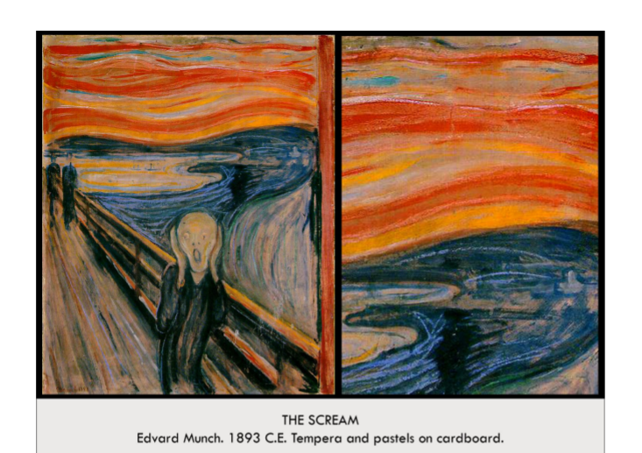

| **Form:** oil tempura and pastel painting on a piece of cardboard. He painted multiple versions of this. Very free and linear, experimental and abstract, looking forward in the history of art. Vibrant, strong color contrast. non-naturalistic, skewed proportions, everything swirls into itself, lots of movement and uncertainty- this is to represent the feeling of the moment (SYMBOLISM)  **Function:**An example of symbolism in art. And an example of a proto-expressionist. Expression of the world, of being alive. Feeling all alone in a hostile universe. Semi-autobiographical, an expression of the themes that preoccupied Munch: relationships, life, death, dread. recounts an experience he had when walking with friends, struck with a sense of melancholy at the shocking sunset, how to portray grappling with the intense cry of nature? A study in different mediums, part of a series of four renditions of the same scene, called "The Frieze of Life", each using different surfaces and materials (this final one being tempera on cardboard), wanted to experiment with these different mediums to see how they may represent a story or a feeling differently  **Content:** About the anxiety of being alive. Landscape is echoing the emoto=ions of the central figure, there are idstordent colors, bright reds mixed of blues, cyan and many others. It is so ugly that it is perfect( once its ugly enough it becomes beautiful.) the figure is clenching his hands and his mouth is open in an eternal scream. The background distorts around the central figure which brings focus to this subject of the painting. On the left side we see his two friends who are walking away. And that side itself seems almost normal in the perspective. androgynous, elongated figure screams with hands pressed to its face in the foreground, two figures walk along the bridge into the background, sea swirls into the sky, everything is streaked and blended and sketchy, power of natural forms calling to an individual  **Context:** He was the proto expressionist who lived in norway. He was very sad and lonely painted-troubled souled. He painted death and suffering very well. Monk is making art about the pain of existence. Created during the end/late impressionism in europe. His art was a piece that lead to the future of art. It was first exhibited in 1895. “ the angles of fear, darkness and death have been by my side for a long time” one of the worlds most famous paintings. Relation to Synesthesia: Synesthesia is the synthesis of the senses, some people may associate a smell with a musical note, or a color with a smell. The Scream's swirling synthesis of the forces of nature may reflect some understanding of or relation to synesthesia (or maybe just a general sense of being overwhelmed and pulled in different directions by natural senses)  **Compare:**  **122**  Late Europe & Americas |
| --- |

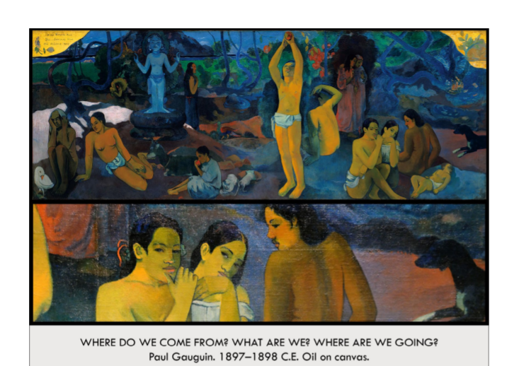

| **Form:** Very large painting 12ft 2in , oil on canvas. Movement: Symbolism, Artist: Paul Gaugin. continuous narrative, like fresco, or friezes, weird multi-perspective view in background. Symbolist, colors play an important role, 2-dimensional. symbolic meaning, expressive, non-naturalistic  **Function:**Manifesto for stages of life. enigmatic, multiple philosophical interpretations, essentially a private work, whose meaning was only known most personally to Gaugin himself  **Content:** Tahitian natives in scenes that show the stages of life (from right to left): infancy, adulthood, old age, figures are partially unclothed, dressed in a non-western fashion. Flat fields of inventive color, most of the painting is deep deep blues, they are all buttressed by 2 fields of gold that say where do we come from where we are headed. Tahitian women in all stages in life( there are babys, young girls, women and old women) death is represented by the statue  **Context:** most radical of all of the colorest of the time. He moved to tragedy during the end of his life, when to get away from civilization to find something primitive and honest in his art, something un influenced by paris. He dies by suicude. First artist to make ¨primitive cultures¨  **Compare:**  **123**  Late Europe & Americas |
| --- |

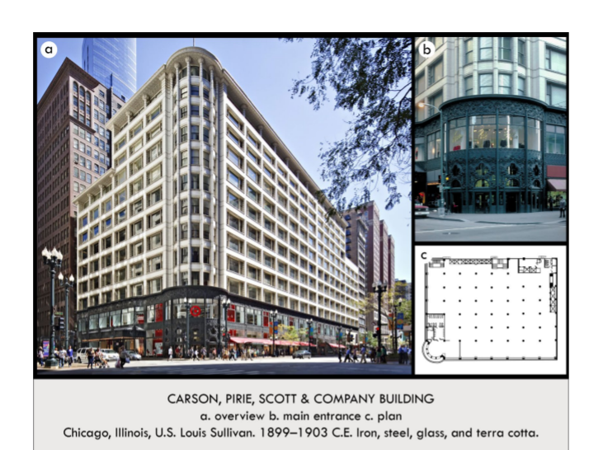

| **Form:** Created of brick and terracotta and each windows is brocken apart by terraces if terra cotta. Art Nouveau decorative program, cast-iron ornamentation covers the corner entryway and ground level exterior, floral, elaborate, intricate, industrial material reflects organic forms (characteristic of art nouveau)The decoration comes out t=of the theme of nature. There were no collomes or anything particularly european. 20th century modernism. Inventive american architecture of decoration and simplicity, which does not hide its function. Painted in 1907  **Function:** Bottom is retail store and the top is an office space- is built for capitalism. Department store, rather than emphasizing the upward, vertical lines to accentuate the height of the skyscraper (as would usually be done), Sullivan highlights the ground-floor level entryway to draw shoppers into the store. Decorative program also served to distinguish the building from the others around it, as well as attract shoppers.  **Content:** built grid-like with a maximum space from windows, the frame was built out of metal. ( made with metal skin) the exterior is holding a decorative roal and is not holding the building, the entire front has a cast iron decorative innovation. The exterior is plan and repetitive. Steel-frame skyscraper. Tripartite is. decorative, open, easily-accessible ground level and first floor. infinite number of stories for offices, all should look the same because they serve the same function, distinct attic story and cornice line, to cap/mark off vertical endpoint and set it apart from other buildings in the cityscape. tweaks the tripartite form to serve a different purpose, highlights the horizontal ground floor space rather than the usual vertical trajectory of the middle section, gives ground floor larger windows to emphasize the shopping space, welcoming, aesthetically pleasing, decorative. Circular entrance, first 2 floors plate glass surrounded by cast iron.  **Context:** He was the first modern architect. All about form following function of the building ( his motto) Divergence from traditional vertical effect of the ideal skyscraper (even his own earlier skyscrapers) in chicago (birthplace of the skyscraper) Art Nouveau. industrial materials (Chicago boasts: steel manufacturing, train hub) reflect organic forms (aesthetic floral intricacies). He was a chicago architect n=and had success ( the city had burnt to the ground before) his first commission was a large opera house, he conceived of something radical, he did not want the architecture of the foreng country( that shows power). There was no illusion to the past. Frenzy and diabolical energy. It was extremely shocking at the time. Was a breakthrough of the time( 400 years of painting comes to the end) renaissance is being raided in for the creation of the artist( for them to be imaginative and not follow a formula.)  **Compare:**  **124**  Late Europe & Americas |
| --- |

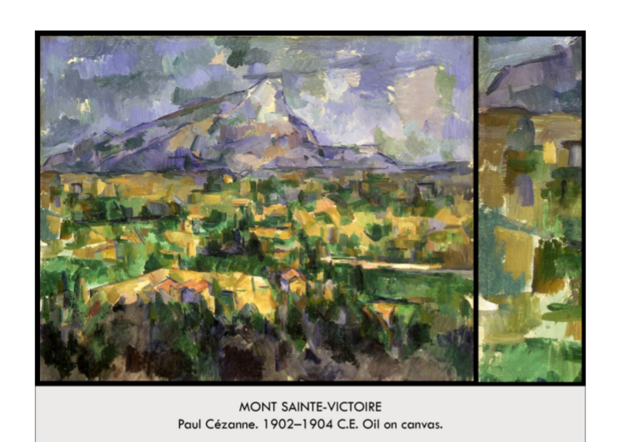

| **Form:**  Oil on canvas . Part of a series of the same scene from different angles  **Function:**  Decoration **“ make an impression**  **Content:**  Schematic grid of brushstrokes and colores. Apart od a series of painting called “Mont Saint Victoire” Bottom half is completely 2D ( very radical)  **Context:**  He paints the experience of seeing instead of the optical realist, when you look at anything and you close your eyes, what do you see? He builds his entries paintings out of blocks. Disrupting the art of the period and perspective. “Depicting something is not the job of paint/ or art”  **Compare:**  **125**  Late Europe & Americas |
| --- |

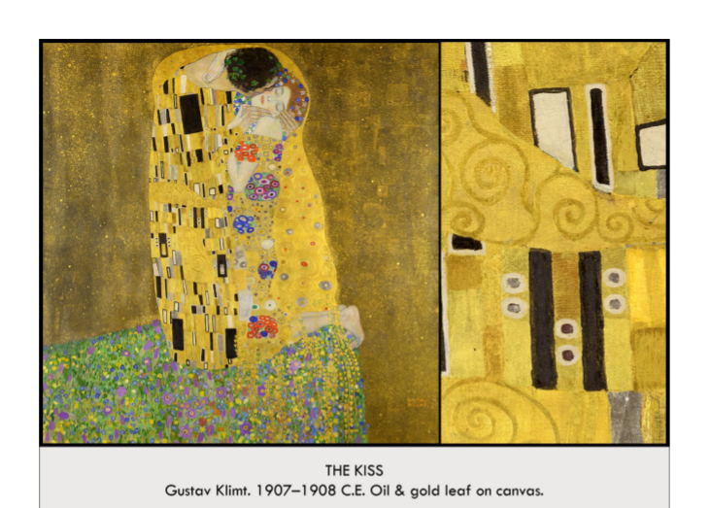

| **Form:** Oil and gold leaf on canvas. Part of a series of gold paintings.  **Function:**Not a portrait, but a piece of symbolism. And decorative art. suggest all consuming love and passion— permanence  **Content:** a kissing couple on a precipice, little of the human form is seen, her face is calm and passive, but with eyes closed very passionate. his neck has a sense of physical power and desire, large, richly designed patterning on clothing, male is more rectangular; female more circular, reminds us of a religious icon with the gold - v byzantine, v medieval Created of almost every single golden substance they are more then 8 types of gold leaf, some gold is flat and some are on top of other things they give it death. Put a portrait on an imaginary background. Male garment it rectangles and straight lines and the womens are curves and angles, So there are gender roles. Somes joy and it is an ecstasy and decoration.  **Context:** Art Nouveau, Brussels, Barcelona, Paris, Vienna, 1890-WWI. seeks to eliminate separation of artistic mediums and combine them all into one, a lot of vegetal and floral patterns, complex design, undulating surfaces. During Modernization of Vienna, in a time of chaos, an eternal and universal kiss. Known as the last word on love. Maybe a attempt to bring back gold and say it is the most precious thing we have so he aligned it wath love. The work has been endlessly reproduced and his message has been lost to time is some extent. Gold reflects what society holds sacred. ( shows that the most sacred thing at the time might have been money) a piece that was part of the vienna succession.  **Compare:** Church of Sain vitale= the mosaic of the church, gold tesserae( cover ceramic with gold) Portrait of Justian and theodora and their attendants. Scream (dissonance and symbolism)- the opposite of that.  **128**  Late Europe & Americas |
| --- |